Managing your Club Remotely

Due to ongoing changes and updates concerning COVID-19 sent out both nationally and at the state level student organizations are no longer allowed to hold practices, rehearsals, meetings or any other type of activities that require members to get together physically. This includes on and off campus meetings as an organization.

Campus life and organizational involvement is a quintessential component of the student experience that looks differently when working with online students. Maintaining your organization while we host academic courses online is as important now as it ever was. This is an opportunity to provide a virtual platform to sustain peer connections and relieve students from the potential solitude they are experiencing.

This document is meant to act as a guide to help all Mines organizations stay as active as possible during this time frame.

Remember, we are here to help you.
Also, if you or any Oredigger you know if facing hardships finding food, first necessity items, etc. please let us know.

Hosting Meetings Online

Setting-Up Zoom

- To activate your account visit www.mines.zoom.us and select the “Sign In” Icon
- Your account will be labeled as a “Basic Account,” limiting your meetings of more than two participants to 40 minutes.
- If you are interested in scheduling a Zoom training, please email bruiz@mines.edu

Digital Meeting Best Practices

- Test all your technology (speaker, Wi-Fi, camera, remaining battery life, etc.) before your meeting begins.
- Do not work on other tasks during a meeting whether that be on your computer, phone, or other medium.
- Everyone in the meeting should remain muted with only one person speaking at a time.
- If possible have meeting attendees wear headphones with a speaker to eliminate ambient noise.
- Record your meetings so that you can actively review the conversation and create meeting minutes.
- Encourage meeting attendees to utilize the “Chat” feature for any questions they might have. You can answer them verbally if they are pertinent to the conversation.
- Designate an executive board member as a “Chat” feature respondent. This will be helpful when fielding large group discussion, sharing links, and responding to specific questions to an individual that may not be pertinent to the rest of the group.

Elections

- To host an anonymous poll you can host an election through Engage. Once logged into your account and in the “manage organization” feature of your Engage page you can select the “Elections” option in your tool bar located on the left-hand side of your screen.
- By clicking the “Create Election” icon you will begin the election building process.
- On this screen you will be able to title your election and provide any instruction that might be needed for your members.
- By selecting the “Active” check box you are allowing your members to participate in the election between the dates and times you inputted.
- You will also be able to provide an alert on your organization’s Engage page to indicate your organization is hosting an election by selecting the check box that outlines that feature.
- To limit access to your election only to currently listed organization members select the check box that features this information.
- Once you have completed this form click “Save”.
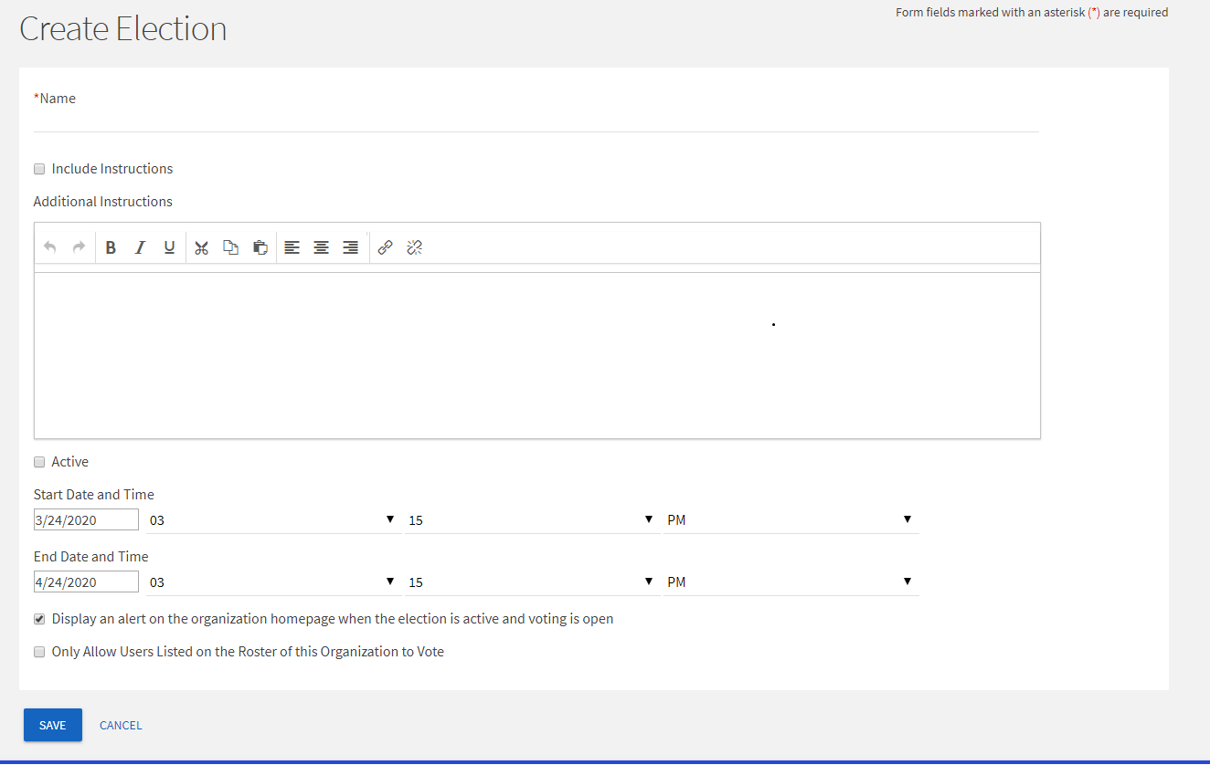

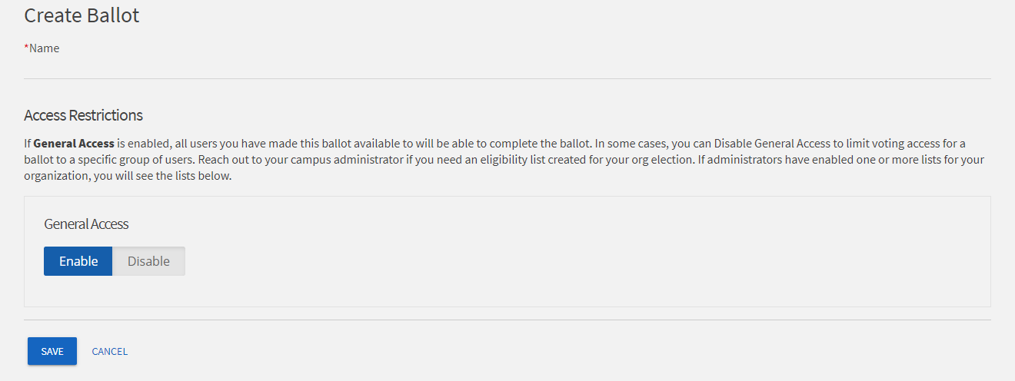
- Once your election is saved you can begin creating your ballot. Ensure that you provide General Access so that all your organization members can participate in your election.

- By clicking save you will now be able to build your ballot. There are multiple types of questions you can ask your members in this form:

  - A “Check Box List” allows your election participants to select multiple answers to the question being asked.
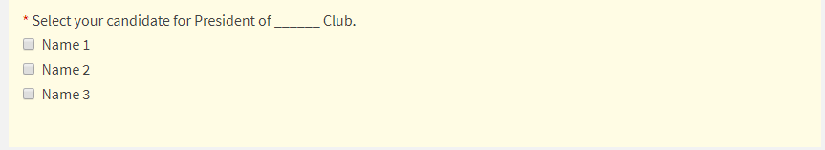
  - A “Radio Button List” allows your election participants to select only one response to the question being asked.
  - A “Text Field” will give your election participants to write their own unique answer to the question being asked.
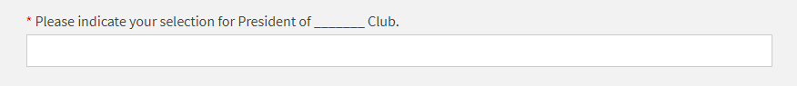
  - “Ranking” gives election participants the ability to prioritize multiple answers to a question.
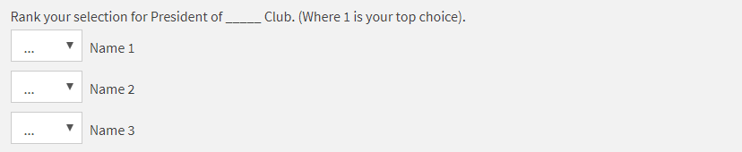
  - “Instructions” will provide participants with a text box that has a prewritten message that they are not able to respond to.
- As you build your ballot the form will automatically save any progress you make.
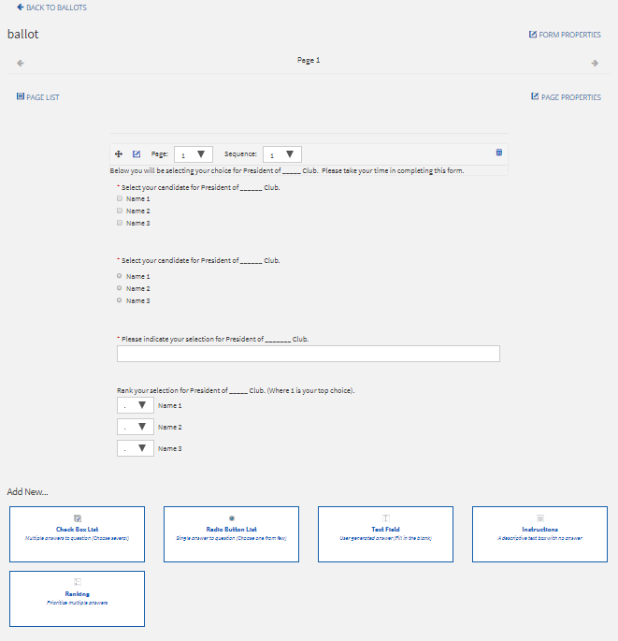

- When you have completed your ballot you can select the “Back to Ballots” icon in the top left corner of your screen.

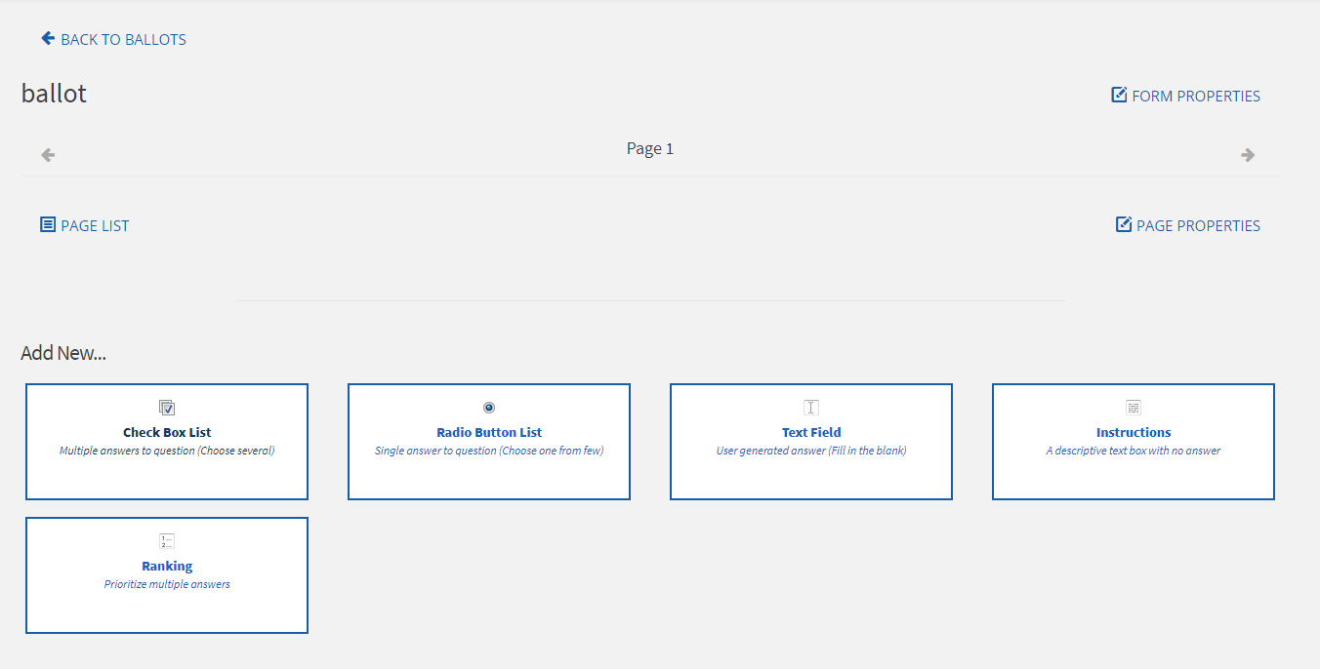

- Ensure that when you have completed your ballot that you have selected the “Active” check box in the election form settings.

Conducting Club Business

- Invoices, Contracts, Logo purchases
  - Send to Begona Ruiz at bruiz@mines.edu with your index number
    - Invoices – send invoice, W-9 from payee and your index
    - Contracts – DO NOT SIGN, just send us the contract, your index and contact information for the entity your want to contract with
    - Logo purchases – send us the artwork, quote from approved vendor (see list at orgs.mines.edu) and your index

- Purchasing
  - Fill out a purchase request – PLEASE NOTE whether you’d like us to purchase it for you or you’d rather purchase it and then get reimbursed
    - SAIL purchases it for you:
      - include direct links to the product(s) to buy and specify quantity
      - include address where items should be shipped (if applicable)
    - You purchase the item with your own funds:
      - Submit receipt, name and CWID to bruiz@mines.edu
      - Refunds will be processed daily to speed up the process
      - These purchases will have tax, but it will be also reimbursed to you
  - Make purchases for items that do not need for your members to get together

- Does your organization need any equipment or software licenses to stay operative and facilitate access and inclusion for all of their members?
  - Make sure you can keep everyone engaged and active. If, due to SARS-Cov2, and to continue club operations, you need any special purchases (i.e. equipment, software licenses, etc.), please let us know.
  - If you need ideas for virtual facilitation of club operations, or are experiencing issues with accessibility, please reach out to us.

- Please, contact Begona Ruiz at bruiz@mines.edu for any questions or needs related to you club operations, purchase requests, and payments, etc.

Transitioning Leadership

- If you have any questions regarding information shared in this video or regarding organizational financial procedures please contact Begoña Ruiz at BRuiz@Mines.edu.
- For quick reference to BSO guidelines and BSO representatives please visit https://orgs.mines.edu/bso/.

Maintaining Your Community

Getting Creative with Your Events/Activities

While your organization’s members might be away from campus making it harder for everyone to come together and meet we can take this opportunity to spread your organizational mission across Colorado, state borders, and in some cases globally. For some organizations this might be easier than for others but with a little creativity and unity across your organization we are certain it is possible.

Using a fitness club as a general example:
- They could create a compilation of training/workout videos to utilizing without a gym.
- They could map out member’s running distance and create a digital map of how far the group has run while not at campus.
- Runners could try multiple trails or tracks and rate their ease, distance, incline, etc. for reference to future club members to utilize during breaks.

Using an arts club as a general example:
- They could create content of local art from multiple towns for their Instagram or other social media account.
- Recently balcony performances have become popular in some European countries. Some version of this for anyone with instrumental talents would be a fun way to spread an organizations love of music with their community.
- Using this experience as a source of inspiration for poems, stories, songs, paintings, etc. would be a nice collaborative project for multiple arts groups to showcase the general spirit and mood of Mines students during this time.

Using a professional organization as a general example:

- Consult your local, state, and national organizations for professional development opportunities.
- Write and submit entries to your organizations to publication journals in your field.
- Contribute to your online community’s forums or create local discord for your organization to take part in.

Using a group based on social change as a general example:

- Share useful tips to reducing your carbon footprint at home.
- Have a donation competition for your local food bank or thrift store where participants share their donations online.
- Find the silver lining in our current situation and share the hope. An example being the water clarity of Venice without mass tourism.

Utilizing Social Media

Get Inspired
Most organizations are going through the same situation we are whether that be at other institutions or on a professional level. There is nothing wrong with taking a look at these other social media pages to see how they are being managed.
For example, if you are a basketball club you could look at the Denver Nuggets page to see what content they are posting. Are they thinking outside the box? If they are posting fun and engaging content on their social media channels, there is no reason you couldn’t apply the same principles to your account.

Get Your Members Involved
Encourage your current members to get involved in your online community. Chances are your members are on social media during this time frame and have been seeing interesting or funny videos, posts, etc. coming from their favorite websites that are relevant to your organizations community. Have them share these items on your channel.

Host a Competition
It is likely that your members are bored and looking for something fun to do while self-quarantining and with all sorts of fun challenges circling the internet there is sure to be some competition you could create of your own. For example have your art club could have a weekly drawing challenge, your theatre club could share monologues to showcase their performance skills, car club could post photos and vote for their favorite club member’s recent upgrades/features added to their vehicle.
Give out prizes for winners to encourage participation on your site. Contact BRuiz@Mines.edu prior to offering prizes.

Mix Up your Content
It is always visually appealing for social media content to be a mix of text, photos, and videos. The trick to engaging a wide population is to cater to them all by having each type of post available to your members to interact with.

Utilizing Engage

Organization Wall
- Think of the organization wall as a discussion board similar to a group of Facebook. It is a communication tool intended for members of your organization to have an open discord with each other.
- Any person who is listed in your organization’s roster will have access to post and comment other member’s posts on your organization’s wall.
- The organization wall can be found at the bottom of your organization’s Engage page.

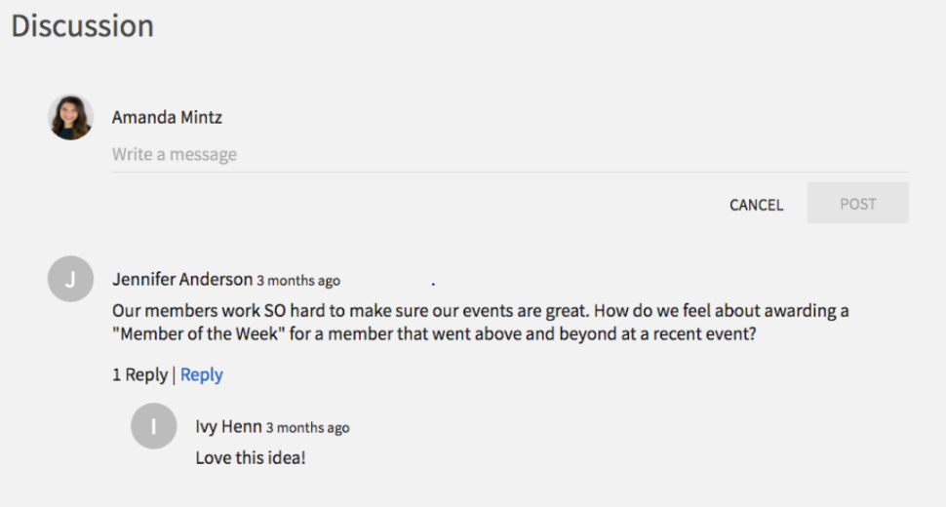

News Articles

- The news article tool acts as a device to easily organize any announcements, stories, blogs, or news story that your organization wants to share with its members.
- The most recently published news articles will appear on your Engage page.
- Older news articles can be accessed by selecting the “View All News Articles,” located above your most recent news articles being displayed on the Engage page.
- Both members of your organization and Mines’ Engage users who are not affiliated with your organization are able to comment and discuss the news article within the news article itself.
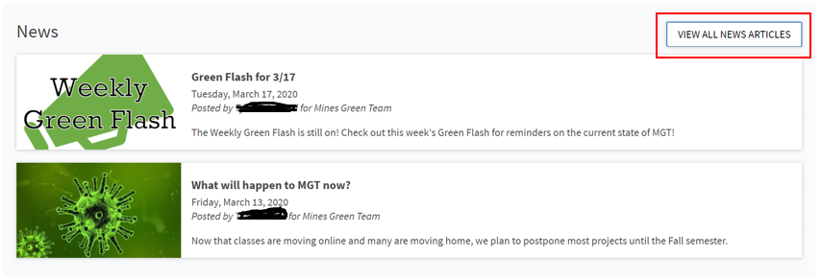
- You can create a news article by selecting the “Manage Organization” icon on your Engage page and accessing the tool bar on the left-hand side of your screen. Once you are within the tool bar drop down list select “News”. This will load a list of all your published news articles with a blue icon in the top right corner of your screen that says “Create Article”. By selecting this button you will be able to start creating your news article.
- On this page you will be able to title your news article, write a brief summary of the content within the news article, upload an image, write the news article itself, select who the article will be visible to, and notify your organization’s members of the post being published.
- Once all the required fields (indicated by an asterisk) are filled out the “Create Article” icon will illuminate blue. By clicking the blue “Create Article” icon you will publish the post for viewing.

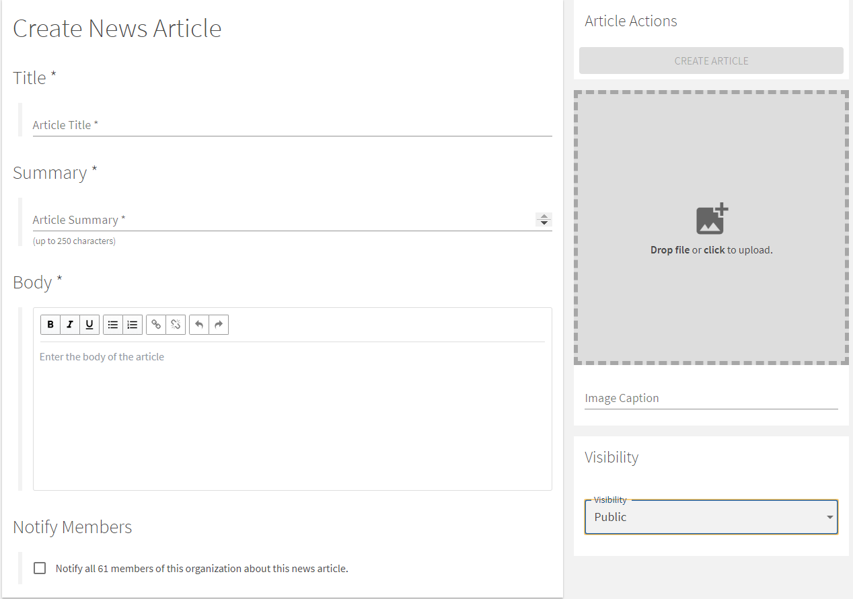

Additional Executive Position Roles

- Managing your organization completely online adds a number of duties onto the already existing responsibilities that each executive board member of your organization possesses. As a leader on your executive team you should take the time to clearly outline what additional roles are needed to maintain an engaged and active club membership.
- Some additional duties to consider are:
  - Zoom meeting host
  - Zoom meeting scheduler
  - Zoom meeting chat facilitator
  - Social media content coordination
  - Engage wall post conversation facilitator
  - Engage news article creator and conversation facilitator
  - Communicating with members remotely

FAQs
How are Zoom meetings saved?
- By default all Zoom videos are recorded. The host has the capability of stopping, pausing, and continuing the recording on their toolbar.
Where can I find my saved Zoom meeting recordings?
- As a default setting all saved Zoom recordings can be found in the host’s document folder.
Do I need a webcam to join on Zoom?
- Meeting attendees do not need a webcam to join Zoom conversations. You will still be able to utilize other functions such as sharing your screen, participating in the chat feature, view other member’s webcam feeds, and listen and speak (should your computer have a microphone).

